**Title:** Lab 8. Bipolar Junction Transistor as a Switch

**Name:** Robert Bara **Partner:** Dalton Hamilton, Mohamad Asaf, Abdulaziz Almersi

**General Objective:** The general objective of lab 8 is to examine how the Bipolar Junction Transistor (BJT) will operate as a switch, by simulating a circuit using Multism and DC analysis.

**Background Activities:** Bipolar Junction Transistors (BJT) are silicon or germanium “doped” devices made of either a PNP or NPN type structure, where in the n-type electrons are majority carriers, while the p-type holes are majority carriers. The BJT contains three terminals: the collector, base, and emitter. BJTs act as current controlled devices, where silicon BJTs operate in the forward bias region when the current from the base-emitter junction exceeds a potential of 0.7V. Furthermore, germanium transistors must exceed 0.3V. Applications of a BJT can operate as an amplifier within a circuit, or act as switch, depending on where the position of the $Q$ operating point starts. When the $Q$ point is within the middle of the IV characteristic, the operation region is within the active region and a signal fed into the amplifier will swing evenly amongst positive and negative portions. This is the idea of a class AB amplifier. If the $Q$ point initializes within the cutoff region, the amplifier is off when there is not any signal feeding through. The amplifier turns on when a signal is fed through and the right polarity is applied, creating a class B amplifier. If the $Q$ begins within the cutoff region but swings into saturation upon feeding a positive signal in, the transistor has an extreme swing and operates as a switch. This lab examines how a BJT can operate like a switch.

**Procedure**

Using a 2N2222A transistor, connect a 1K resistor to the collector, in series with a 12v battery. Select a Pulse voltage input source to have a pulsed value of 5V, rise time of 10ms, fall time 10s, pulse width of 50ms, and period of 100ms. Connect the pulse voltage source to a 1k resistor into the base of the BJT. The circuit should appear as follows:

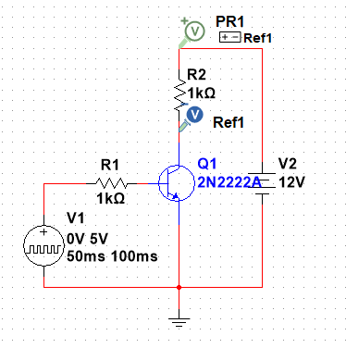

Figure . Schematic for simulation

Conduct a transient response with a stop time of 0.002s to verify the BJT will operate as a switch. If the circuit is indeed acting as a switch, describe how it is operating as one. Considering the base pulse voltage as an input, what is the Vc? Compare the maximum value of V2 and Vc. Based on the results and analysis, ponder why we care about the bandwidth of an amplifier.

**Results:**

* 1. **Simulation Results:** The circuit below shows the BJT in a setup to act as a switch, with a differential voltage probe across the load into the collector, which will help analyze the transient response:



Figure . Circuit schematic for simulation

Upon running a transient response, it is apparent that the BJT is operating as a switch due to the extreme swing from the cutoff region in which the switch acts in the off position, to the active region where the “switch” is now on. The BJT tries to pass the saturation region. Also performing circuit analysis when the voltage at the base VB is the input signal with a max of 5V, and VCC is the DC 12V voltage source, and the voltage at the emitter is grounded so it is 0V and 0A. Performing KCL to find IC, IC=IB+IE. Since VE=0V (Grounded), IE=0A, meaning IC=IB. IB=5v/1k=5mA. IC=IB=5mA. Therefore, VC=Vcc-IC*RC=12V-(0.005A*1000Ω) =7V. Therefore, the transistor is acting as a switch, switching between 0V to 7V which is further shown in the transient response. Although the transistor is within the saturation region from the point of 1.2ms to 1.6ms, it is only for 0.4ms to switch operating regions due to the collector current building up while the voltage across from collector to emitter falls towards zero. The results for the BJT acting as a switch is as follows:

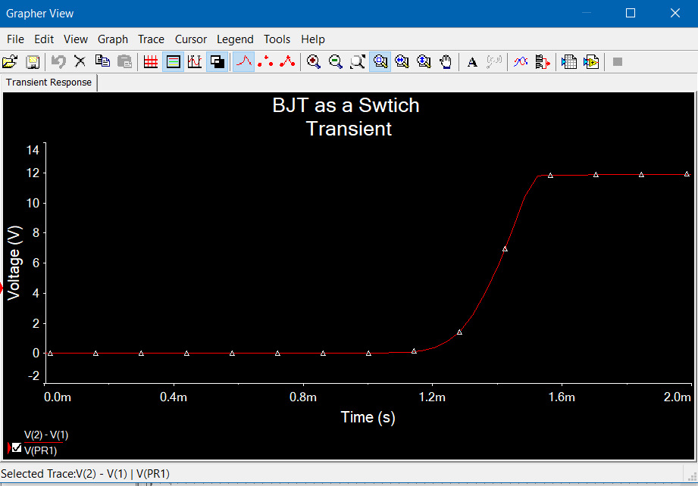

Figure . Transient Response of BJT acting as a switch

1. **Conclusion:**

Over the past few weeks, each laboratory has solidified an application of transistors, beginning with MOSFETs, then to BJTs. This laboratory explains how a BJT can act as a switch by examining the transient response when wired as shown in figure 2. Knowing the bandwidth of an amplifier can be extremely useful for amplification of signals such as audio, given the range of human hearing is 20 Hz to 20 KHz, therefore keeping this in mind will determine the parameters for any sort of filtering. In the case of the BJT acting as a switch, knowing the bandwidth is also important when feeding in an input signal to the base, given that the gain (hFE) will become 1 when the operating frequency is reached. This also ensures the BJTs limitations and can be seen upon plotting hFE vs frequency.